

**test report**

**组    别：                        Group 03**

**项目名称：  路橙-aging travel APP**

**团队名称：                  人间小橘子**

目录

1. Overview 3

1.1.Project background 3

1.2. Test Objective 3

1.3. Test scope and method 3

1.4. Test environment 5

1.5.End of Test 5

2. Test process 5

2.1. Tester 5

2.2. Test process description 5

2.3. Test Schedule 7

2.4. General overview 7

2.5. Test case execution rate 8

3. Test results 8

3.1. Conclusion 8

3.2. Recommendation 8

3.3.Summary 8

# 1.Overview

## 1.1.project context

The elderly population is growing. Data from the seventh national census in 2022 show that China 's population aged 60 and over

18.7 % of the total population and 13.5 % of the total population are 65 years old and above. The ' 2022 China Aging Survey Report ' shows that from 2010 to 2020, the population aged 65 and above increased by 4.63 percentage points. Compared with the previous decade, the increase was increased by 2.72 percentage points. As the population ages, how to bridge the digital divide among the elderly has always been a hot issue of social concern. In November 2022, the General Office of the State Council issued the Notice on the Implementation Plan for Effectively Solving the Difficulties of the Elderly in Using Intelligent Technologies. Encourage technology companies to provide related applications ' care model ', ' elder model ', and stressed that enterprises should closely meet the needs of the elderly characteristics, strengthen technological innovation, to provide more intelligent aging products and services.

Therefore, the Road Orange APP came into being, integrating voice assistant, one-click alarm, bus route query, remote control and other functions, which is committed to bringing convenience to the elderly.

## 1.2.test target

1.2.1.Interface program coverage of 100 % ;

1.2.2 interface error modification rate of 100 % ;

1.2.3. 100 % functional coverage of test cases ;

1.2.4.Execution rate 100 % ;

1.2.5.Modified test problem regression test coverage of 100 % ;

1.2.6. Test record closed loop rate of 95 %

## 1.3.Test range and method

Test methods and test cases are tested multiple times according to the test items given in the ' test case ' document, and the requirements are tested, mainly including the following tests :

1.3.1.Functional testing, including the following steps :

|  |  |  |
| --- | --- | --- |
| name | description | remark |
| smoke testing | Cases designed to validate the normal mainline process of this function | This case is designed for smoke testing, usually only one case per sub-function, designed to ensure that the normal operation of the function process ( that is, only enter the necessary valid data ) through |
| Overall planning verification | Use cases designed according to the overall rules provided in the requirements document. It mainly includes the consistency of each function page style, the consistency of operation habits, the unity of display format and so on. | Generally, the overall rules of a project are fixed. It is necessary to ensure the execution coverage of the case and avoid the redundancy of the case. Therefore, the overall rules can be designed by one person and directly reused under each module. When the test is executed, the execution statistics can be performed as needed. |
| Page Output Verification | Perform this function operation, the page must be entered / selected items, whether in the case of empty can still pass the submission check. | Each page must lose different items, to consider the display of must lose items, and non-must lose items are also made must lose restrictions. |
| Page input validation | It mainly refers to the inspection of the legitimacy of various input data items on the client. | This part of the case mainly refers to the client can verify or limit the content, such as data input length limit, whether contain illegal characters. |
| Page Linkage Verification | It mainly refers to the check of whether other items are constrained according to the results of the previous item between multiple input or selected items in the page. | nil |
| This functional process validation | The operation of the current function itself and the test of the correctness of the data flow, including normal process and abnormal process. | For example, perform the transfer operation, enter the correct and wrong password to get the correct normal and abnormal return results ; and whether the returned result displayed is consistent with the actual result. |
| Background thread verification | Verify whether the automatic thread set by the system is executed correctly at a fixed time. | For example, the system is set to 1 a.m. every day, a system automatically from the host synchronization network data updates. |

1.3.2.compatibility test

|  |  |
| --- | --- |
| Compatible objects | test key |
| Other mainstream software | APP |
| If you open other mainstream software at the same time, will it cause conflict ( such as QQ, MSN, etc. ) | Availability of the various functions of the page, interface display beauty, consistency |

1.3.3 Performance testing

A. Load test

①Increasing pressure until the expected performance index is exceeded or a resource reaches saturation

②The pressure that the system can bear can be found

③Can cooperate with system tuning

B. Fatigue test

1. A long time to make the system under certain pressure, to see whether the stable operation
2. Make CPU or other resources at a high utilization rate, continue to run a certain time, and pay attention to the overall operating conditions
3. To increase the CPU pressure, can be equivalent to a small pressure for a longer time running effect, equivalent to ' compression time test '

**1.4.testing environment**

Mobile test environment : flutter latest

Admin : linux centos7

Database system : redis

Network environment : gigabit network

## 1.5.End of test

1. Test case execution rate is 100 %

2.After the system is tested, the defect of level 1 cannot be left

3. The closure defect rate is over 95 per cent

# 2.test procedure

## 2.1.Testers

Testers :

Chenuo : Test Manager

Work Content : Writing Test Report Defect Management Test Results Analysis

Zhou Miaolan : Performance Test Engineer

Work Content : Analysis of Software Function Development Script Performance Test Execution

Yang Yang, Zhong Xiaojia : Automation Test Engineer

Work content : Writing scripts to automate test execution

Hu Wenjing, Pan Chenlu : Black Box Test Engineer

Work content : Writing test cases to execute test report defects

## 2.2.Test process description

2.2.1.Test Planning Phase

A. Testing plan

The test manager creates a test report based on the requirements report. If this requirement changes, the project test report will be updated according to the change.

B. Review test plan

①The project manager browses and reviews the test report.

②The test manager is responsible for updating the test report.

③Project manager is responsible for reviewing and approving the updated documents.

④The version of the test report is 1.0, and if the plan is updated, the serial number of the version also changes.

⑤ Test engineers perform test tasks according to the test report.

2.2.2.Test case stage

A. Write test cases

①Analysis requirements report.

②Test engineers write test cases according to the requirements report. ③Smoke test cases need to be created simultaneously.

B. Review test cases

①The test manager is responsible for reviewing test cases.

②The test case will be updated if an error or problem is found.

③The test manager is responsible for filling in updated test cases. We define the initial version of the test case as 1.0.If the file is updated, its version will also be updated at the same time.

3.Test phase

A. Smoke test

The test engineer is responsible for the smoke test according to the project test case, and whether the actual output result of the test case meets the expected result. We mark this use case as pass or fail.

B. System testing

①According to the project test report and project test cases, test engineer is responsible for the execution of test cases :

②When executing test cases :

③If the actual output is the same as the expected output

## 2.3.Test schedule arrangement

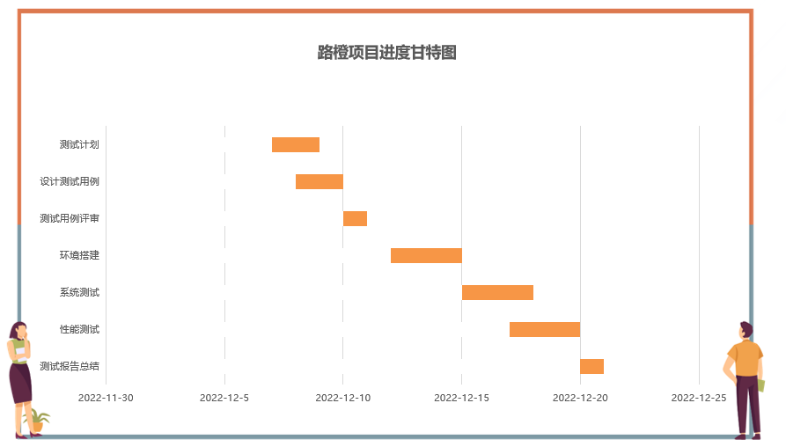

**2.4. General overview**

**Test content :**

**2.4.1 Functional testing :**

Mobile :

Whether passed : Yes

Total defects : no

Back end :

Whether passed : Yes

Total Defects : Very few

**2.4.2.Compatibility test :**

Mobile :

Whether passed : Yes

Total defects : no

**2.4.3.Pressure test :**

Back end :

Whether passed : Yes

Total Defects : Very few

**2.5.Test case execution rate**

**2.5.1.Mobile terminal :**

Number of Level 1 test cases : 104

Number of test case executions : 104

Test case execution rate : 100 %

**2.5.2. Back-end :**

Number of Level 1 test cases : 57

Number of test case executions : 57

Test case execution rate : 100 %

**3.Test results**

**3.1.Conclusion**

The test plan was launched from November 2022 to December 21,2022. It has undergone a total of multiple tests and repair iterations. In multiple tests, the project has shown good performance and successfully passed all Level 1 test items and test cases. The pass rate reached 100 %, and the system did not leave Level 1, Level 2, and Level 3 defects. The remaining Level 4 defects were less than 5 % of the total test samples, reaching the expected level of product requirements. Based on the above data, the program test conclusion of this release version is passed and can enter the next stage.

**3.2. Suggestions**

At present, there are only very few level 4 defects in the system. The problems exposed in this test may have a certain impact on the use of users. It is recommended to fine-tune and iterate again.

The product due to the use of new cross-platform technology, there may be some impact in the future product belt